DATABASE MANAGEMENT LAB
LAB Report
Submitted in partial fulfilment of the requirement of the degree of
BACHELORS OF TECHNOLOGY
to
K.R Mangalam University



Submitted by: Submitted to
Lucky Kumar Ms. Mansi Kajal
(2401010012)

Department of Computer Science and Engineering
School of Engineering and Technology
K.R Mangalam University, Gurugram- 122001, India
Batch – 2024-2028

Experiment : 1
Question 1. Consider following databases and draw ER diagram and convert entities
and relationships to relation table for a given scenario:
COLLEGE DATABASE
STUDENT (USN, SName, Address, Phone, Gender)
SEMSEC (SSID, Sem, Sec)
CLASS (USN, SSID)
SUBJECT (Subcode, Title, Sem, Credits)
IAMARKS (USN, Subcode, SSID, Test1, Test2, Test3, FinalIA)
Solution:
- The entities STUDENT, SEMSEC, SUBJECT, and IAMARKS are identified and represented using rectangles.
- The attributes are represented using ellipses:
o STUDENT: USN (Primary Key), SName, Address, Phone, Gender
♣ USN is underlined as it is the Primary Key.
♣ Phone is shown as a single-valued attribute.
o SEMSEC: SSID (Primary Key), Sem, Sec
♣ SSID is underlined as the Primary Key.
o SUBJECT: Subcode (Primary Key), Title, Sem, Credits
♣ Subcode is underlined as the Primary Key.
o IAMARKS: USN, Subcode, SSID, Test1, Test2, Test3, FinalIA
♣ USN, Subcode, and SSID together form a composite key.
♣ Test1, Test2, Test3, and FinalIA are normal attributes.
- Primary keys are represented by underlining the attribute names.
- CLASS is drawn as a relationship (diamond shape) between STUDENT and SEMSEC.
- The relationship between STUDENT and SEMSEC through CLASS is M : 1, meaning many students belong to one semester and section.
- The M : N relationship between STUDENT and SUBJECT is resolved using the associative entity IAMARKS.
- The relationship STUDENT – IAMARKS is 1 : M, indicating one student can have multiple internal assessment records.
- The relationship SUBJECT – IAMARKS is 1 : M, indicating one subject can have multiple IA records for different students.
- The relationship SEMSEC – IAMARKS is 1 : M, showing that marks are maintained semester-section wise.
- All entities, attributes, relationships, primary keys, foreign keys, and cardinalities are clearly represented in the ER diagram.
ER DIAGRAM:
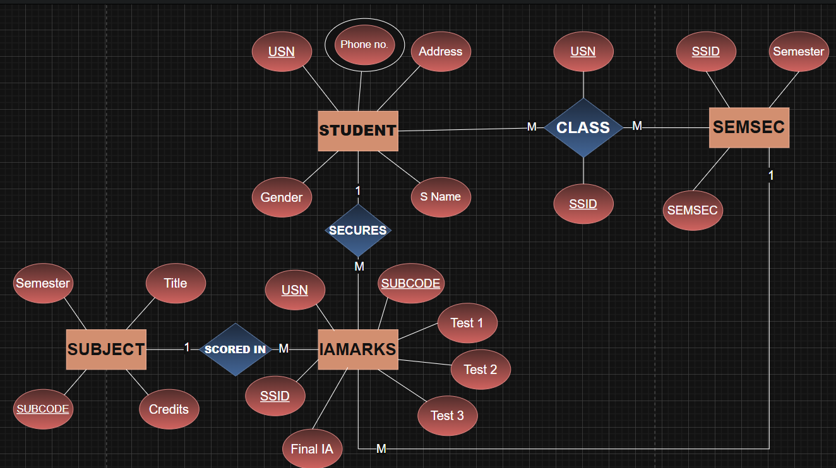

Experiment : 2
Question 2. Consider following databases and draw ER diagram and convert entities
and relationships to relation table for a given scenario:
COMPANY DATABASE
EMPLOYEE (SSN, Name, Address, Salary, Sex, SuperSSN, DNO)
DEPARTMENT (DNo, DName, MgrSSN, MgrStartDate)
PROJECT (PNo, PName, PLocation, DNO)
DLOCATION (DNo, DLoc)
WORKS_ON (SSN, PNo, Hours)
MANAGES (SSN, DNo)
Solution:
- The entities EMPLOYEE, DEPARTMENT, PROJECT, and DLOCATION are identified and represented using rectangles.
- The attributes are represented using ellipses:
o EMPLOYEE: SSN (Primary Key), Name, Address, Salary, Sex, SuperSSN, DNO
♣ SSN is underlined as it is the Primary Key.
♣ SuperSSN is a foreign key referencing EMPLOYEE (self-relationship).
♣ DNO is a foreign key referencing DEPARTMENT.
o DEPARTMENT: DNo (Primary Key), DName, MgrSSN, MgrStartDate
♣ DNo is underlined as the Primary Key.
♣ MgrSSN is a foreign key referencing EMPLOYEE.
o PROJECT: PNo (Primary Key), PName, PLocation, DNO
♣ PNo is underlined as the Primary Key.
♣ DNO is a foreign key referencing DEPARTMENT.
o DLOCATION: DNo, DLoc
♣ DNo and DLoc together form a composite key.
♣ DNo is a foreign key referencing DEPARTMENT.
o WORKS_ON: SSN, PNo, Hours
♣ SSN and PNo together form a composite key.
♣ Hours is a descriptive attribute of the relationship.
- Primary keys are represented by underlining the attribute names.
- The relationship WORKS_ON is drawn as a diamond between EMPLOYEE and PROJECT with M : N cardinality, indicating that:
  - One employee can work on many projects.
  - One project can have many employees.
  - Hours attribute represents the number of hours worked.
- The relationship MANAGES is drawn between EMPLOYEE and DEPARTMENT with 1 : 1 cardinality, indicating:
  - One employee manages one department.
  - Each department has one manager.
- The relationship between EMPLOYEE and DEPARTMENT (via DNO) is M : 1, meaning:
  - Many employees work in one department.
- The relationship between DEPARTMENT and PROJECT is 1 : M, meaning:
  - One department controls many projects.
  - Each project belongs to one department.
- The relationship between DEPARTMENT and DLOCATION is 1 : M, meaning:
  - One department can have multiple locations.
- A recursive relationship exists in EMPLOYEE through SuperSSN, representing that:
  - One employee can supervise many employees.
- All entities, attributes, relationships, primary keys, foreign keys, and cardinalities are clearly represented in the ER diagram.
ER DIAGRAM:
